Power BI Project - HR DATA Analysis Dashboard

- Imported Excel file “HR Dataset.xlsx”
- Prepared data by removing duplicated merging Empfirstname and emplastname columns.
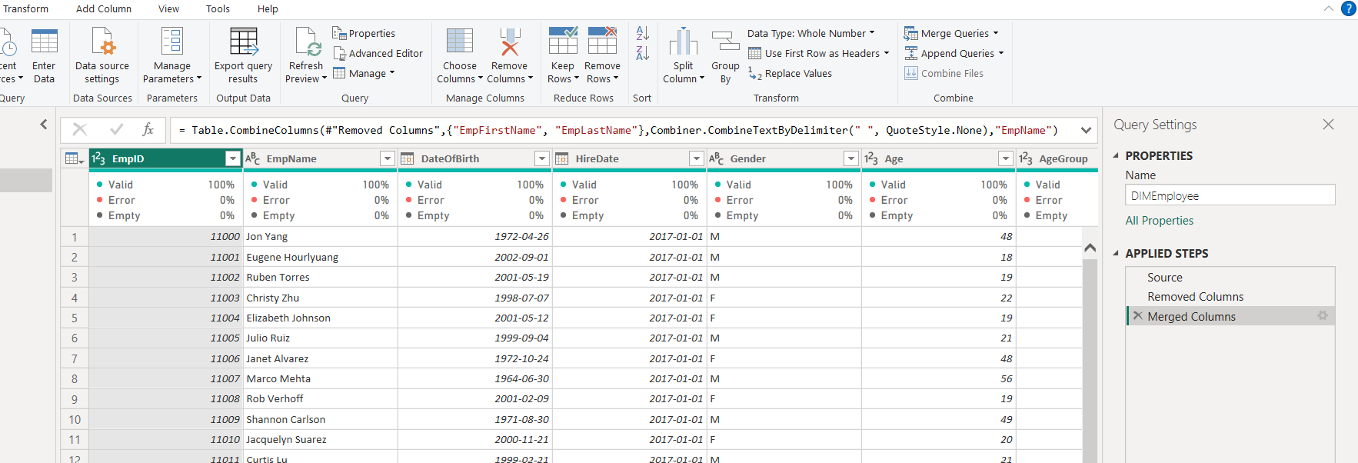

- Using DIMEmployee Table created DIM Tables and FACTSalary Table

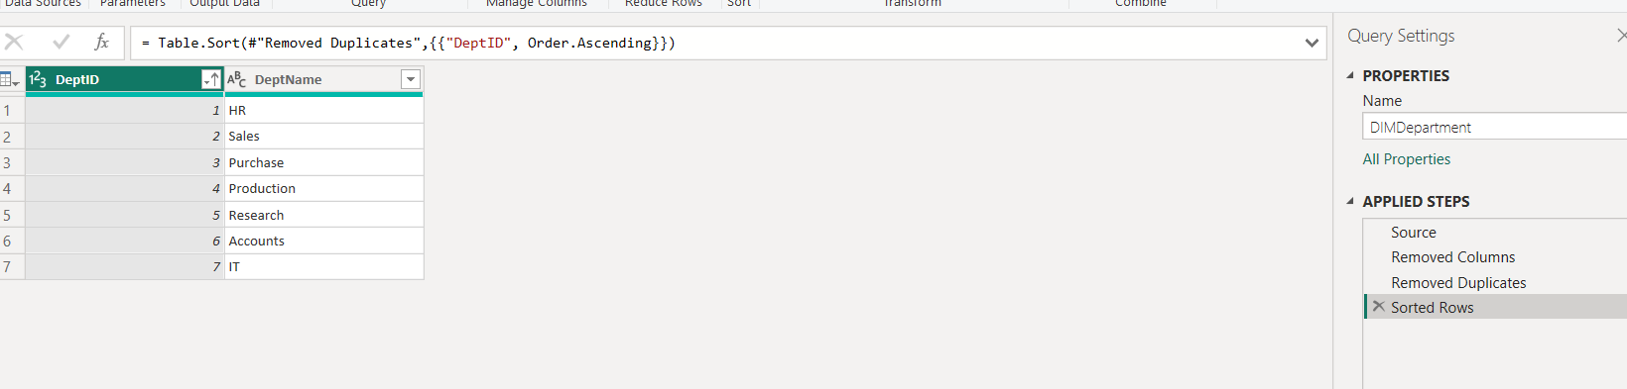

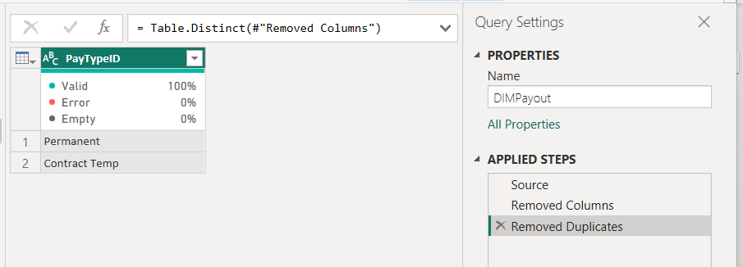

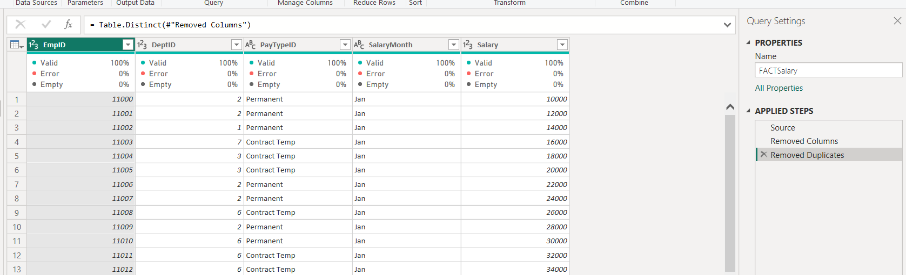

- Created few measures using DAX:

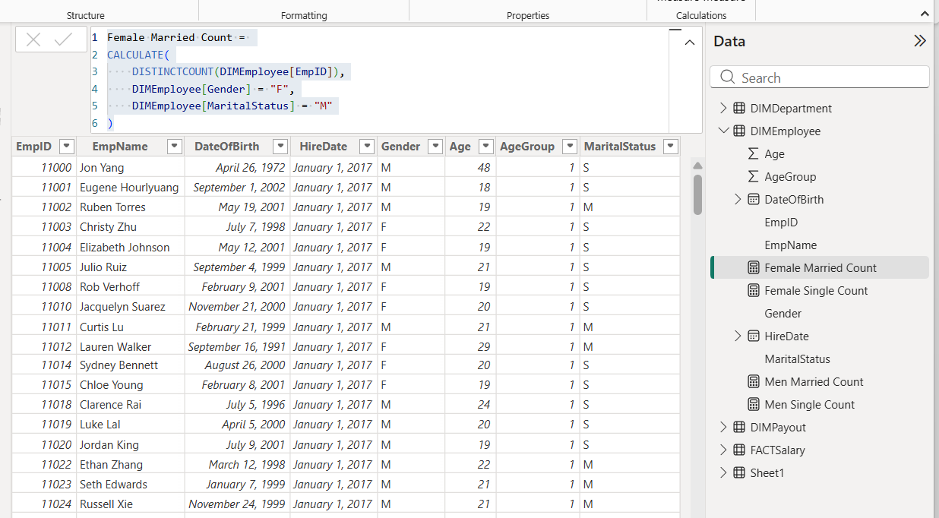

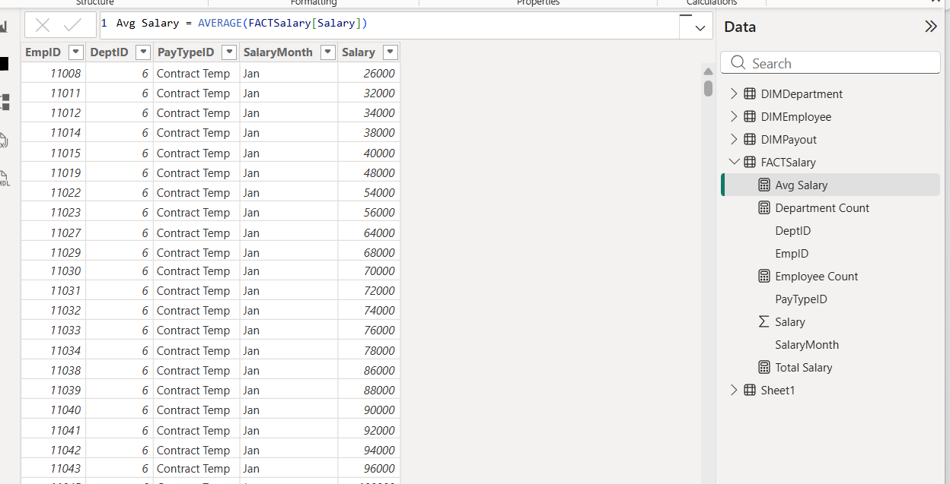

- Completed Data Modelling – Table Relationships (one to Many)
- Empid from DIMEmployee to Empid of FACTSalary
- Deptid from DIMDepartment to DeptID of FACTSalary
- Paytypeid from DIMPayout to Paytypeid if FactSalary
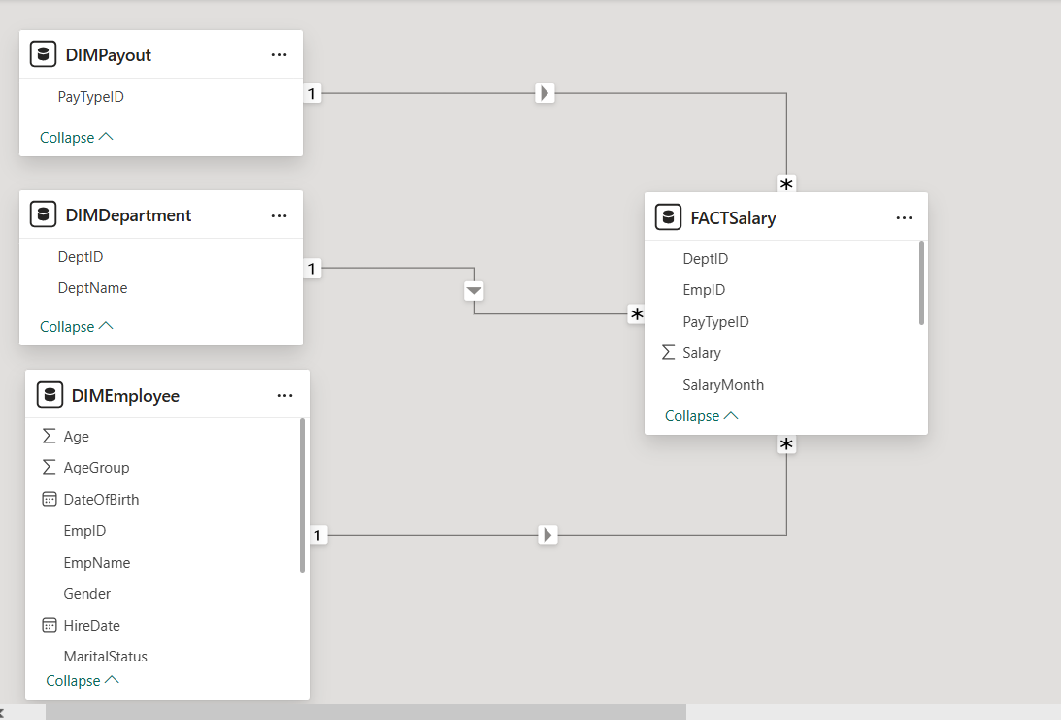

REPORTS: Created 5 page report including first page as “DASHBOARD”:
Notes: In the Dashboard I’ve Created Bookmarks, then created those Bookmark buttons. Also added a page navigation on each page directing it to next page. At last page the navigation button directs it to Dashboard again.
Additionally added NCPL company logo on first Page (Dashboard) top right corner.

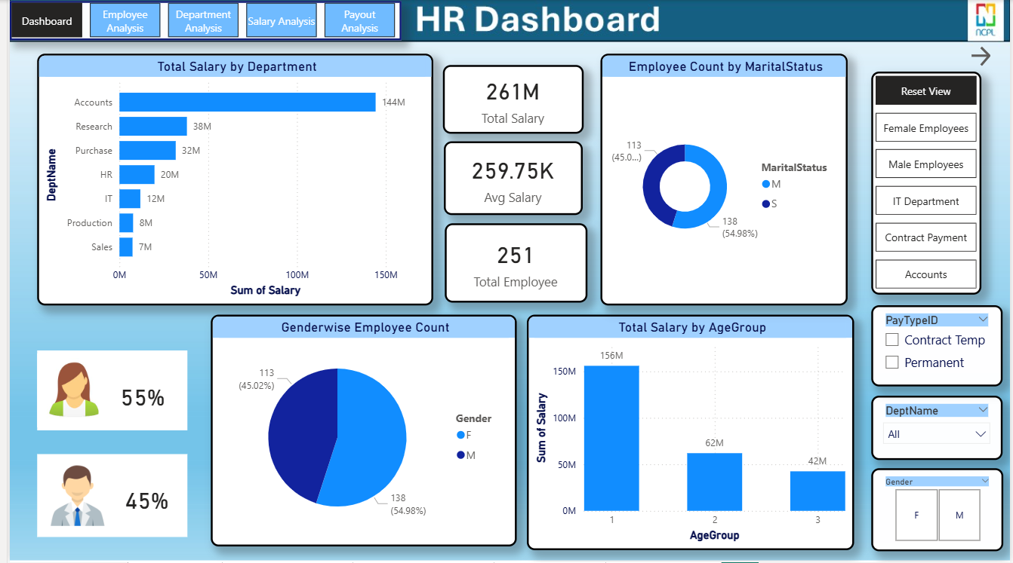

Second Page as “Employee Analysis”

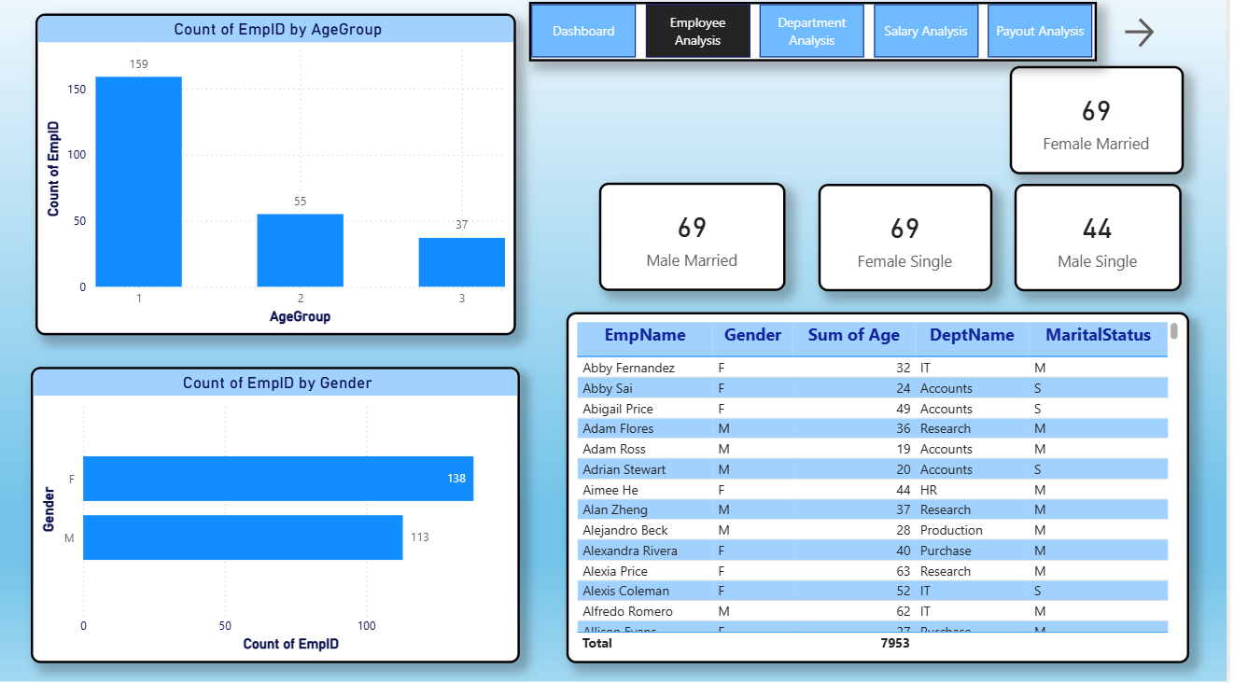

Third Page as "Department Analysis”

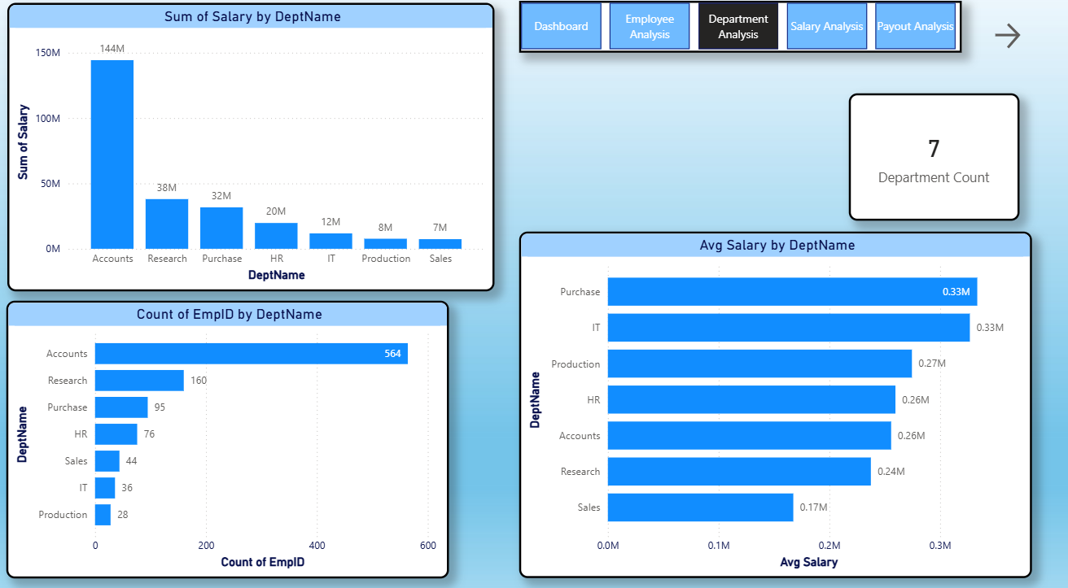

Fourth Page as " Salary Analysis”

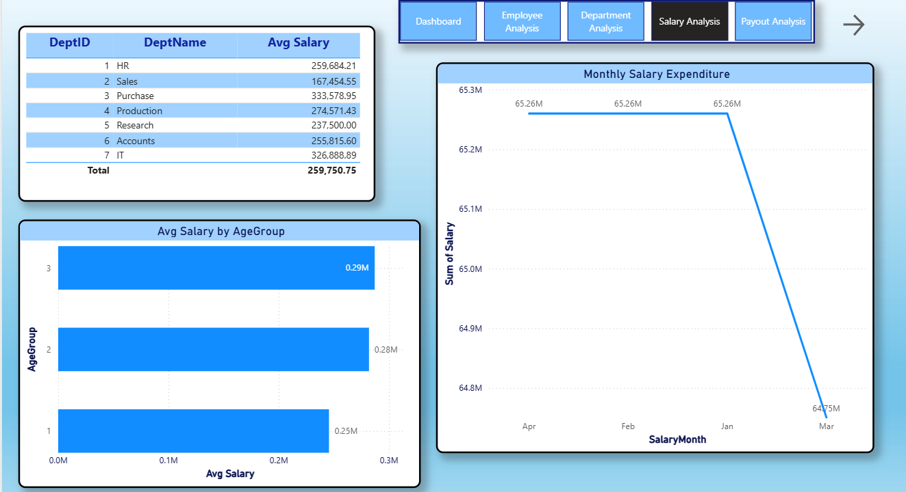

Fifth Page as "Payout Analysis”

